HEALTHCARE Analysis

Table of Contents

- Introduction
- Project Vision
- Problem Statement
- Project Objectives
- Project Scope
- Key Questions
- Strategic Workflow
- Timeline
- Expected Outcome
- Resource Required
- Conclusion

- Introduction
This Healthcare organizations generate a large amount of patient data every day. This data includes patient age, gender, medical conditions, hospital admissions, billing information, medications, and test results. Proper analysis of this data can help hospitals improve patient care and make better decisions.
In this project, a healthcare dataset containing 55,500 patient records and 15 attributes will be analyzed. Before starting the analysis, a strategic plan is prepared to define the project goals, scope, data sources, analysis methods, timeline, and possible risks. This report provides a roadmap for completing the healthcare data analysis project in an organized and systematic way.
Healthcare data analysis is the process of collecting, organizing, and analyzing patient information to support better medical decisions.
The dataset selected for this project contains information such as:
- Patient Name
- Age
- Gender
- Blood Type
- Medical Condition
- Date of Admission
- Hospital
- Doctor
- Insurance Provider
- Billing Amount
- Room Number
- Admission Type
- Discharge Date
- Medication
- Test Results
The purpose of this project is to plan how this dataset will be analyzed to identify useful healthcare insights.

- Project Vision

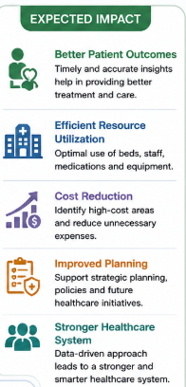
The vision of this healthcare data analysis project is to transform raw patient data into meaningful information that supports better healthcare decisions and improves hospital services. By analyzing the provided healthcare dataset, which contains patient demographics, medical conditions, admission details, billing information, medications, and test results, the project aims to identify important patterns and trends that can help healthcare professionals make informed decisions.

Problem Statement
Healthcare organizations generate large amounts of patient data every day, including demographic details, medical conditions, hospital admissions, billing information, medications, and laboratory test results. Although this data contains valuable information, it is often not fully utilized due to the lack of a structured analysis process. Without proper planning and analysis, hospitals may face challenges in identifying disease trends, managing resources efficiently, monitoring treatment outcomes, and making informed decisions.
The main challenge is to develop a well-structured healthcare data analysis strategy that ensures proper data understanding, cleaning, analysis, and visualization. This strategic planning will serve as the foundation for identifying healthcare patterns, improving operational efficiency, supporting evidence-based decision-making, and ultimately enhancing patient care while maintaining data quality and privacy.

Project Objectives
The main objectives are:
- Study patient demographics.
- Analyze common medical conditions.
- Compare billing amounts across patients.
- Study admission types.
- Analyze hospital and doctor information.
- Understand patient test results.
- Create useful reports for healthcare decision-making.
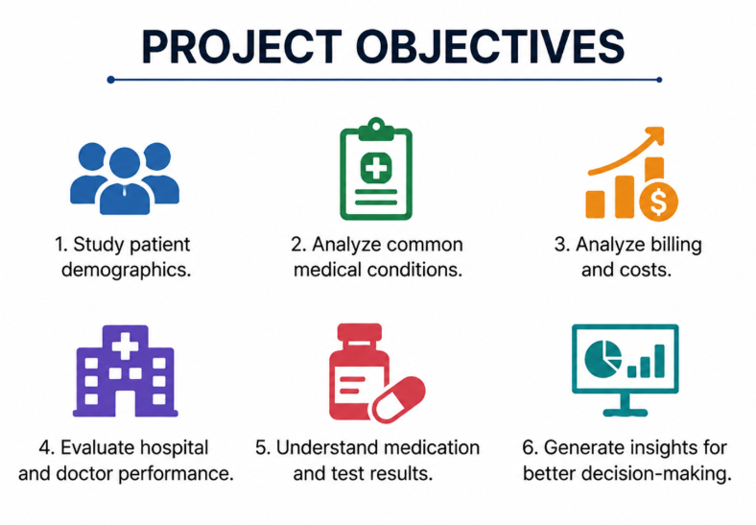

Project Scope
This project will analyze the uploaded healthcare dataset containing:
- 55,500 patient records
- 15 healthcare-related attributes
The project will focus on:
- Data understanding
- Data cleaning
- Exploratory Data Analysis (EDA)
- Data visualization
- Statistical analysis
- Predictive modeling

Key Questions
The project will answer questions such as:
- What is the age distribution of patients?
- Which medical conditions are most common?
- Which admission type occurs most frequently?
- How are billing amounts distributed?
- Which blood group is most common?
- What percentage of test results are normal or abnormal?
- Which hospitals have the highest number of patients?

Strategy Workflow

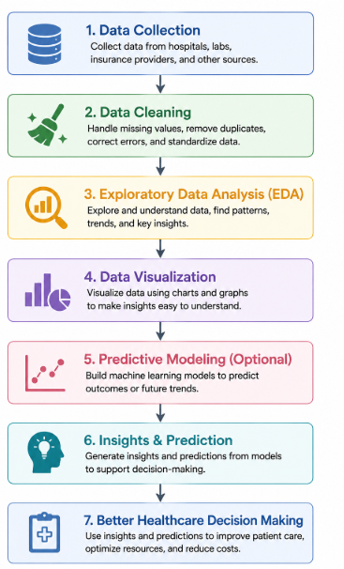

TimeLine
Week | Activity
Week1 | Project Planning
Week2 | Data Collection and Cleaning
Week3 | Data Visualization
Week4 | Statistical Analysis
Week5 | Report Preparation
Week6 | Final Project Submission

Expected Outcomes

After completing the project, we expect to:
- Understand patient demographics.
- Identify common diseases.
- Analyze healthcare costs.
- Generate visual reports.
- Support better healthcare decision-making.

Resource Required

Software
- Python
- Pandas
- NumPy
- Matplotlib
- Seaborn
- Jupyter Notebook

Hardware
- Laptop/Desktop
- Internet Connection

Conclusion

This report provides a strategic plan for analyzing a healthcare dataset containing 55,500 patient records and 15 attributes. It defines the project objectives, dataset scope, analysis strategy, timeline, required resources, and risk management plan. This planning phase establishes a strong foundation for the remaining weeks of the internship, where the dataset will be cleaned, analyzed, visualized, and used to generate meaningful healthcare insights.

